Supplemental Figures
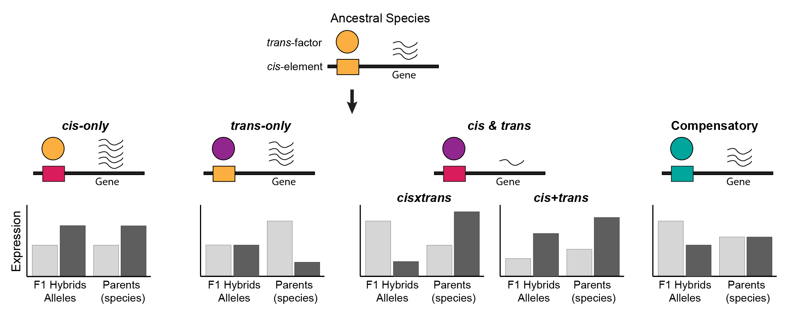
Supplementary Figure S1: Categorization of regulatory divergence using allele specific expression analysis for autosomal genes. Upstream of the gene, rectangular shapes indicate cis-elements (yellow in ancestral species) and circular shapes represent trans-acting factors (also yellow in ancestral species), which are highlighted in different colors to signify divergence. The bar plots represent comparisons between expression of alleles in F1 hybrids and total gene expression of the same gene in C. remanei (light grey bars) and C. latens (dark grey bars) for cis-only, trans-only, cisxtrans (compensatory) and cis+trans(enhancing) and cis-trans compensatory divergence. Different bar heights correspond to significant differences in expression between the distinct allele types as detected by a linear model and post-hoc Wald-type test using CompMap (Sánchez-Ramírez & Cutter 2021; Sánchez-Ramírez et al. 2021).

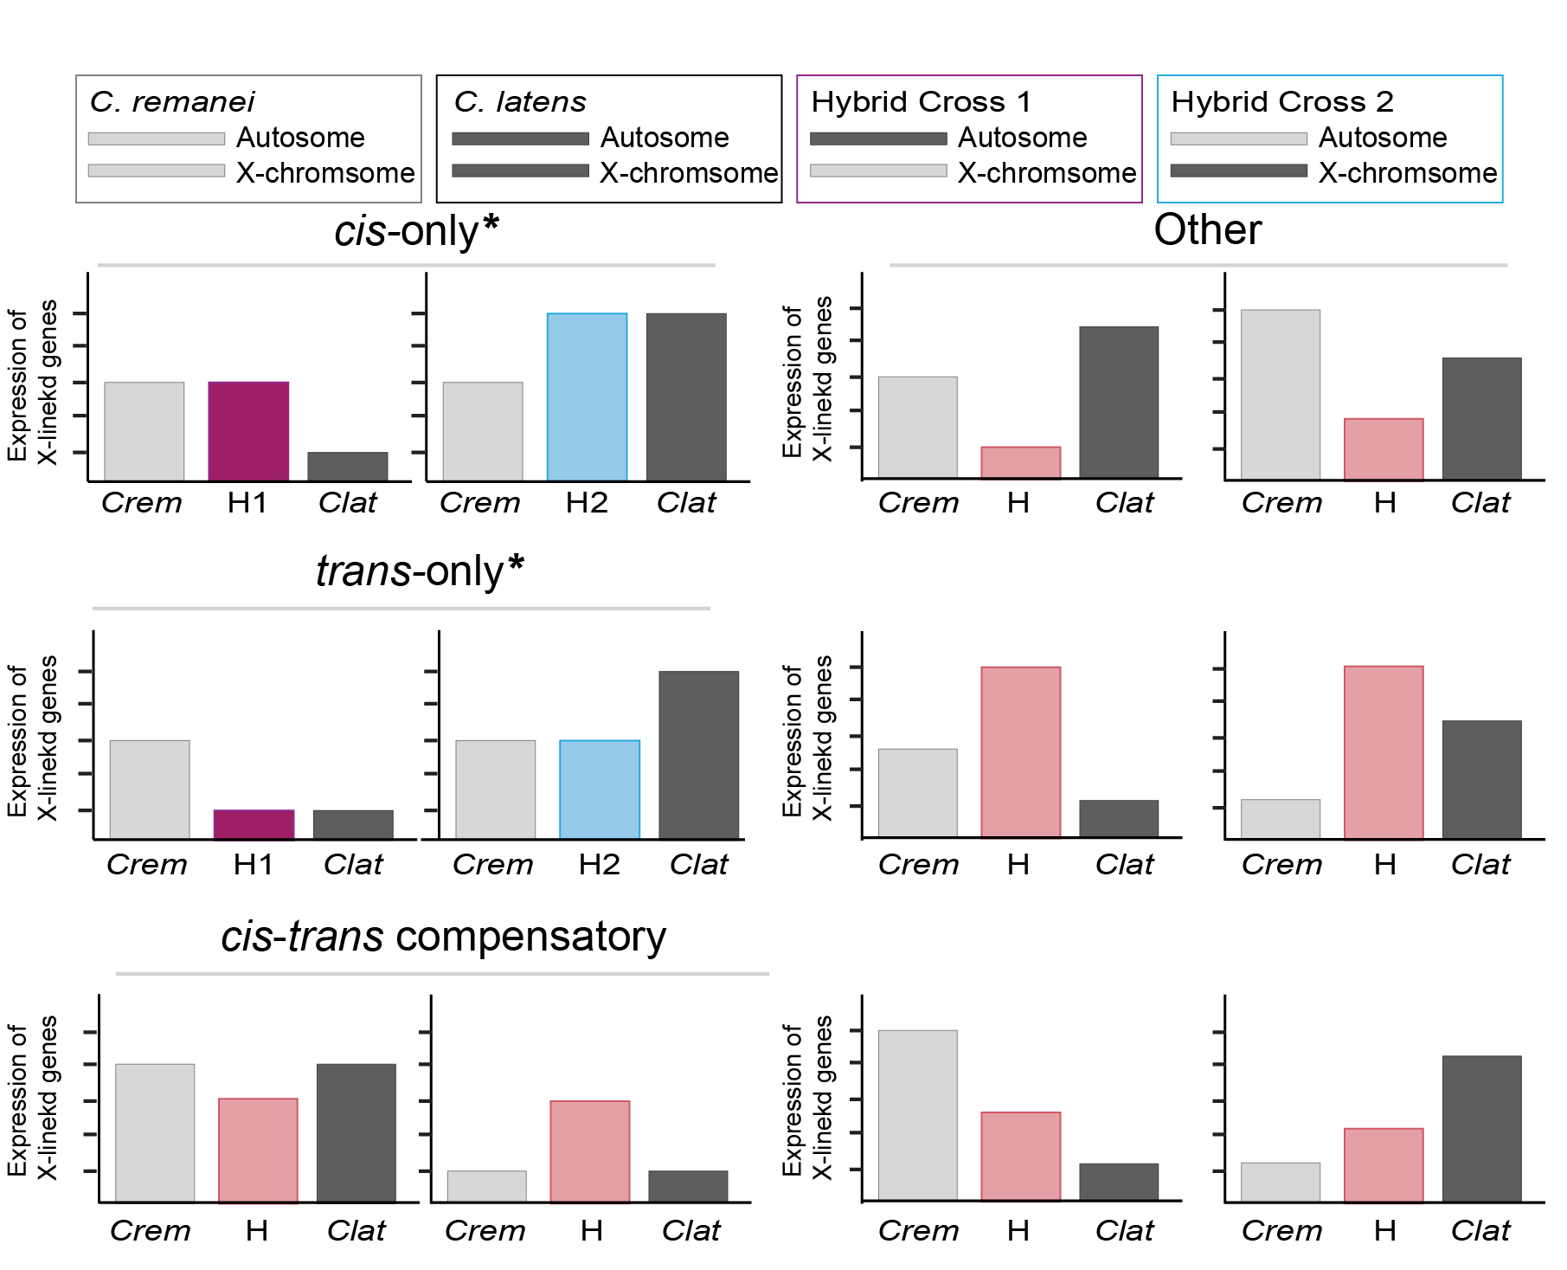
Supplementary Figure S2: Classification of regulatory divergence for X-linked genes in hybrid males. Hybrid males from H1 hybrid cross (pink bars) inherited X-chromosome from C. remanei while hybrid males from H2 cross (blue bars) inherited the X-chromosome from C. latens. trans-acting factors for X-linked genes are assumed to mostly originate from autosomes. Based on this assumption, we classified X-linked genes into distinct regulatory divergence categories, considering how they express themselves compared to the parental gene expression (C. remanei (Crem, light grey bars), C. latens (Clat, dark grey bars)). cis-only*, trans-only* and cis-trans compensatory genes were identified using this approach. All other genes showing significant gene expression deviations were classified under the “other” category with H (red bars) representing both hybrid crosses. The asterisks (*) are used to emphasize that the categorization of X-linked genes displaying cis-only and trans-only divergence was done using different criteria and assumptions compared to autosomal genes.

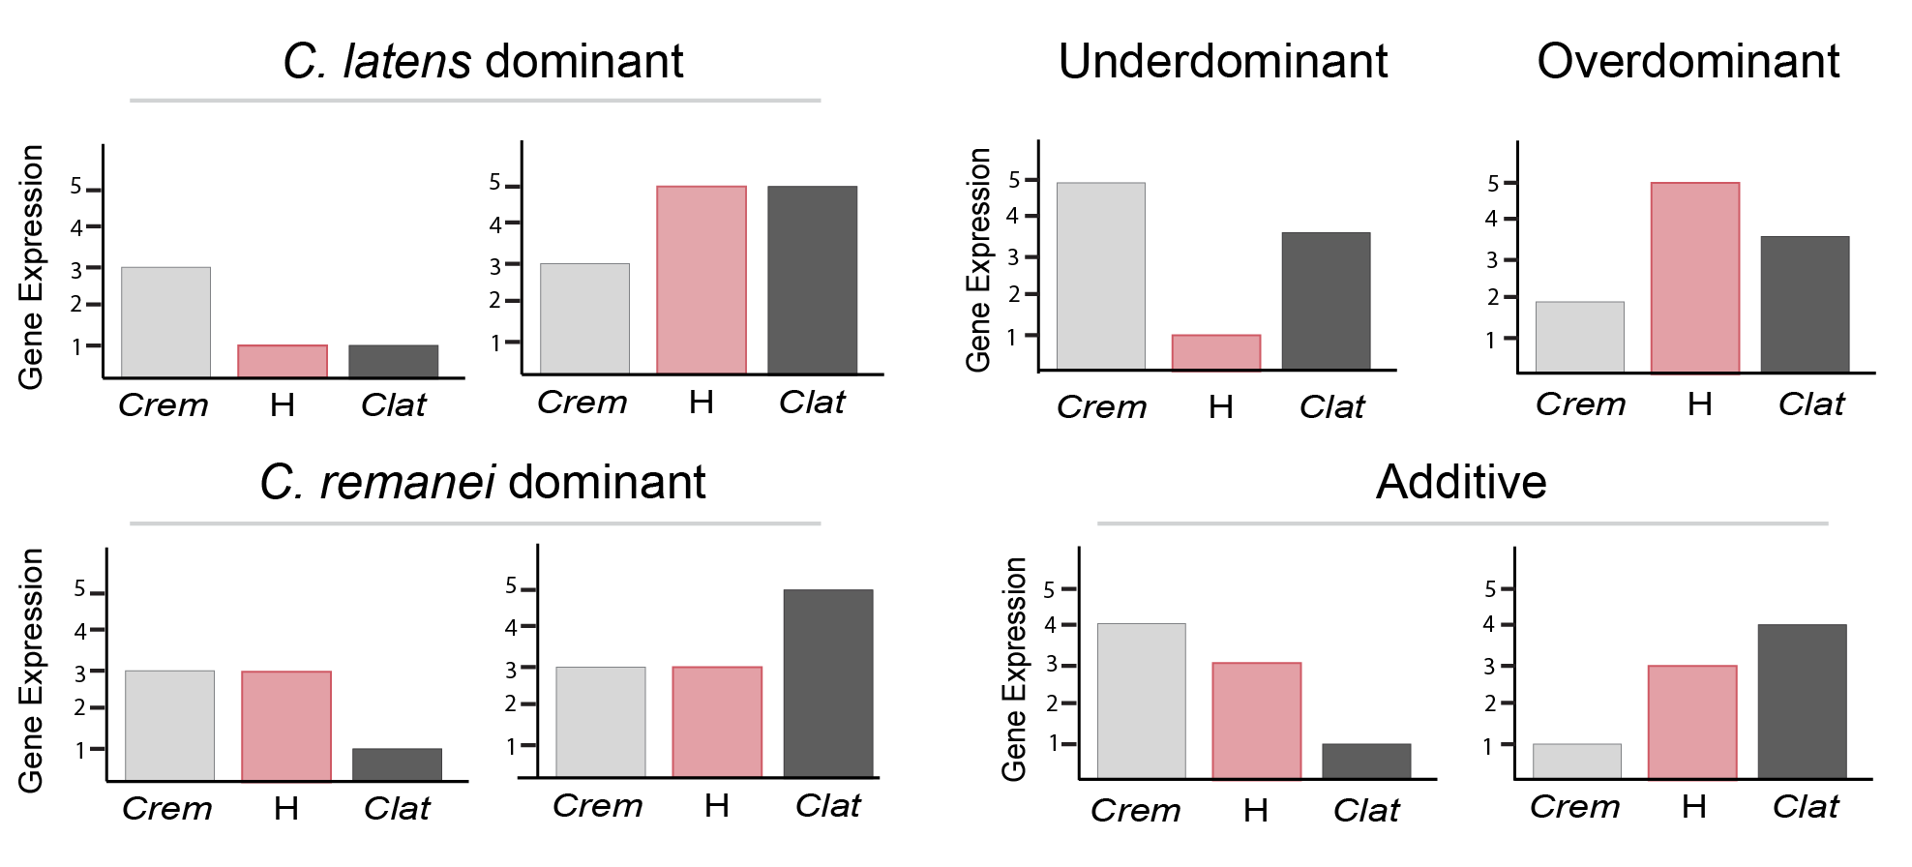
Supplementary Figure S3: Classification of expression inheritance in F1 hybrids. A 3-way comparison between expression in C. remanei (Crem, light grey bars), C. latens (Clat, dark grey bars) and hybrids (red bars) was used to infer gene expression inheritance. Underdominance and overdominance expression represent transgressive expression in hybrids.

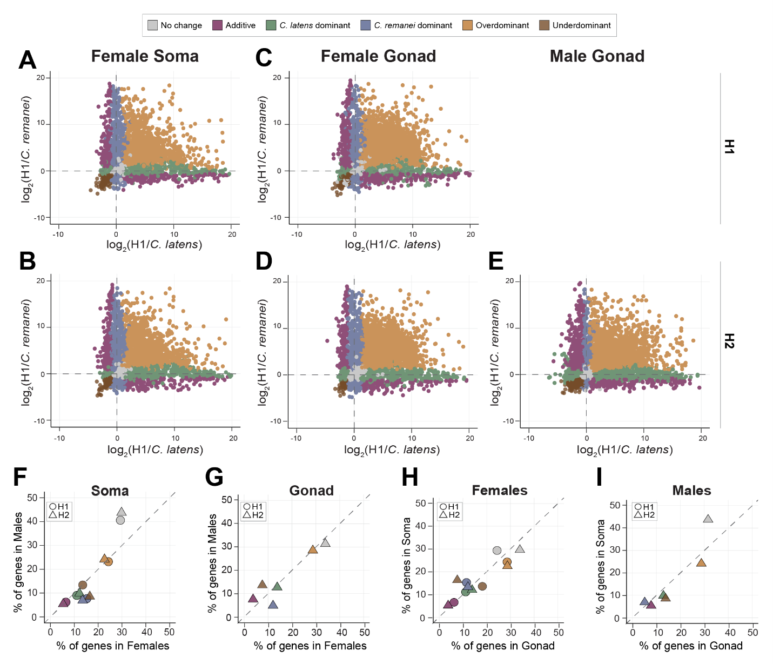
Supplementary Figure S4: Transgressive expression is pervasive across sexes and reciprocal hybrid crosses. Scatterplots visualizing different gene expression inheritance categories based on log fold change relative to each parental species in hybrid female soma (A, B), female gonad (C, D) and hybrid male gonad (E). Owing to the difficulties in reliably isolating hybrid male gonads, we did not acquire expression data from the hybrid male gonad in the H1 cross. (F, G) Scatterplots that contrast percentage of genes in males (y-axis) and females (x-axis) across soma (F) and gonad (G) identify sex-biased inheritance patterns for inheritance categories that do not lie on the y=x dashed line. (H, I) Scatterplots that contrast difference in abundance of genes between soma (y-axis) and gonad (x-axis) for females (H) and males (I)) identify tissue-biased patterns of gene expression inheritance from off-diagonal categories. Both H1 (maternal C. remanei hybrids) and H2 (maternal C. latens hybrids) have male and female somatic tissue samples, but only H2 has male gonad tissue samples. H1 and H2 hybrid crosses are represented by circle and triangle respectively.

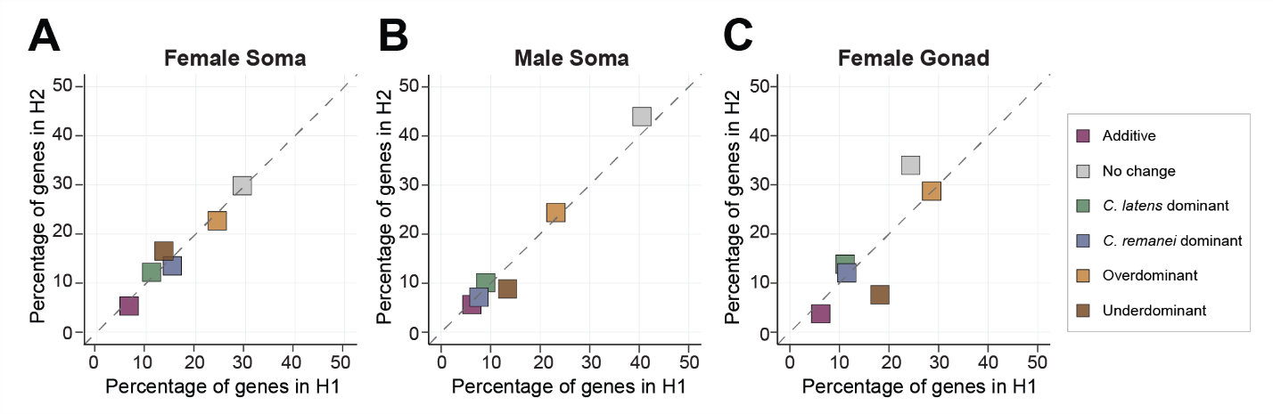
Supplementary Figure S5: Transgressive expression across reciprocal crosses. Scatterplots comparing the proportion of genes in different expression inheritance categories between H1 (maternal C. remanei hybrids) and H2 (maternal C. latens hybrids) in the female soma (A), male soma (B) and female gonad (C).
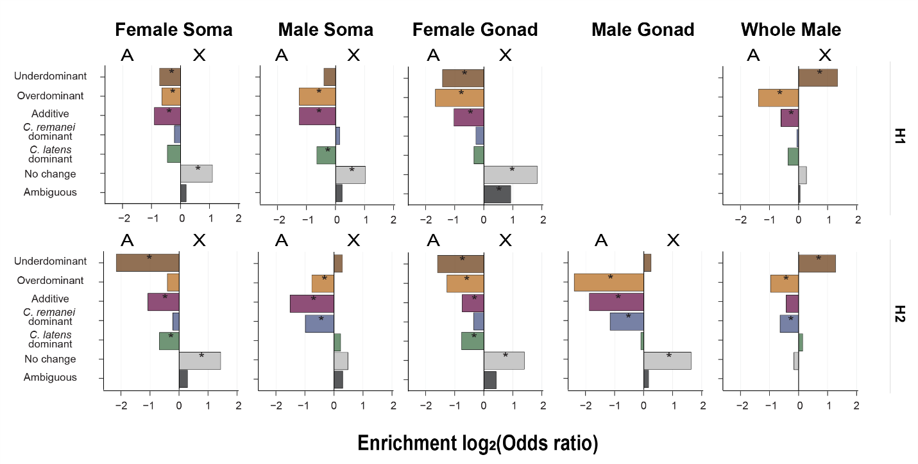
Supplementary Figure S6: Enrichment of genes showing different gene expression inheritance profiles in F1 hybrids. Positive log₂ odd ratio values indicate an enrichment on X-chromosome and negative values indicate an enrichment on autosomes. We used the Fisher exact test and represented significant enrichments with * for p<0.05.
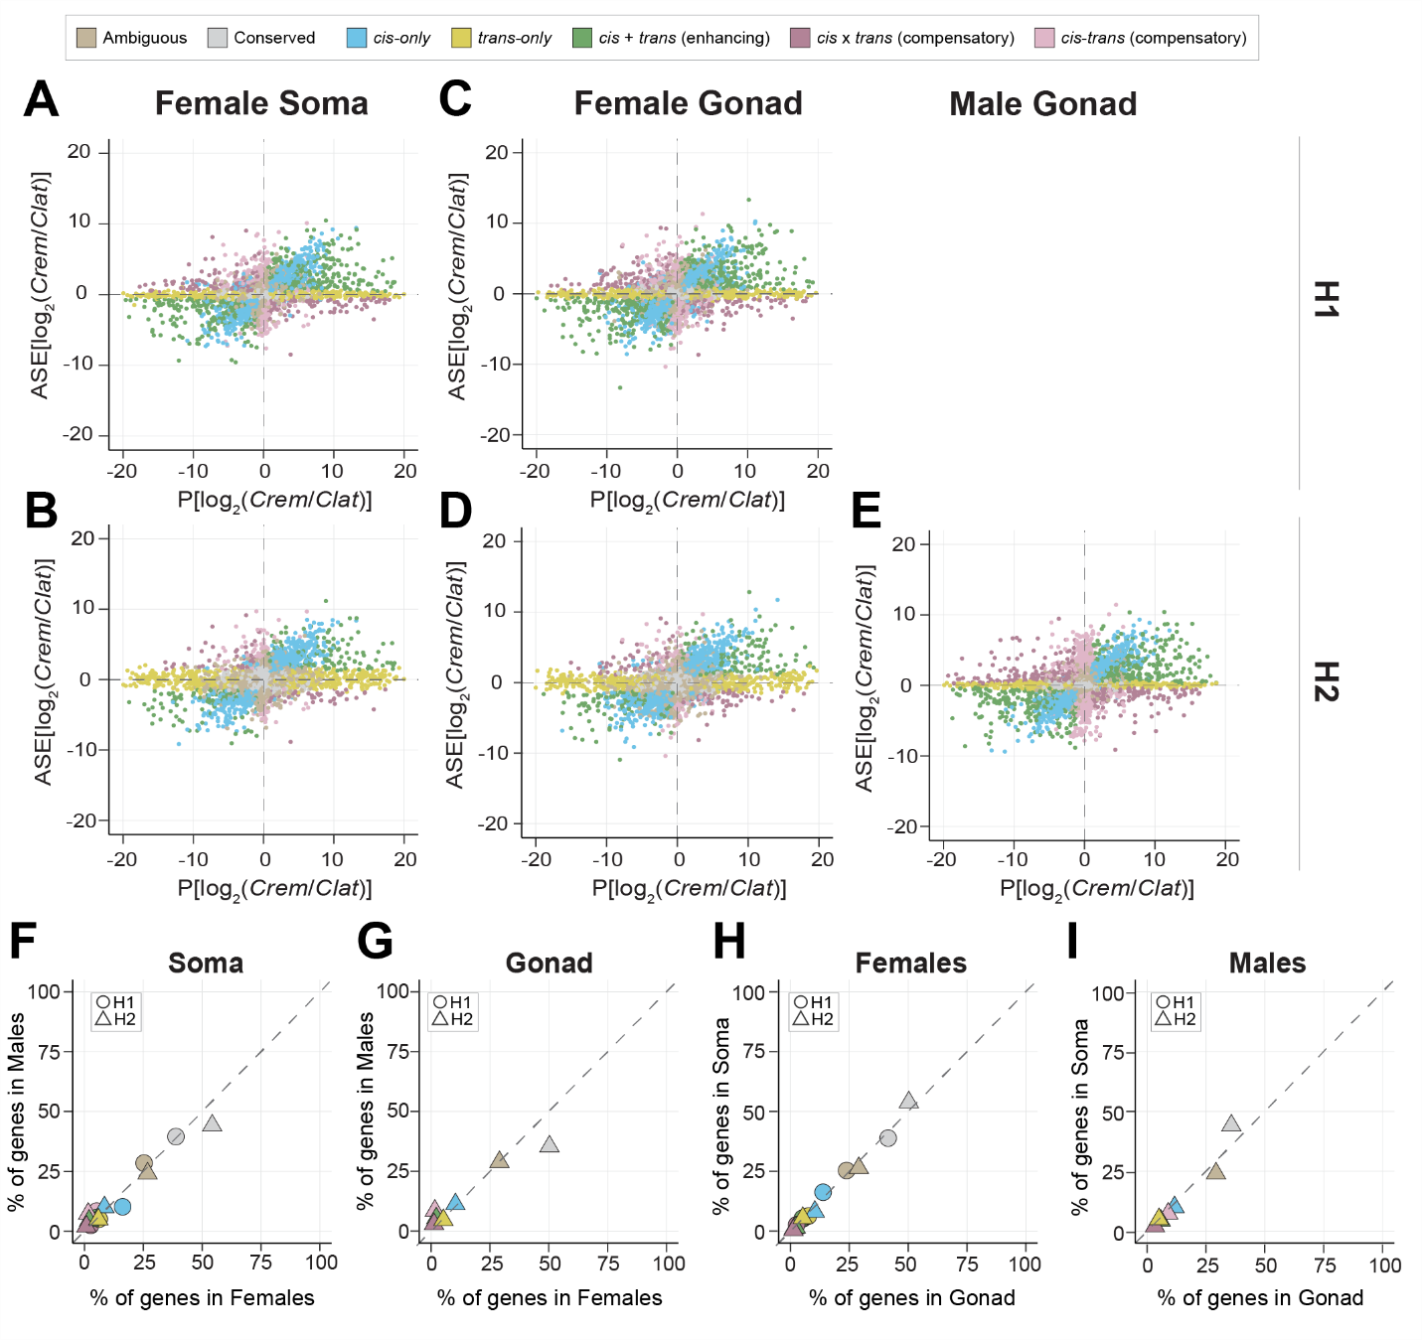

Supplementary Figure S7: Regulatory divergence is widespread across sexes and reciprocal crosses.
Scatterplots visualizing different gene expression divergence categories based on allele specific expression analysis for autosomal genes expressed in hybrid female soma (A, B), female gonad (C, D) and male gonad from hybrids cross 2 (E). (F, G) Scatterplots contrast percentage of genes in males (y-axis) and females (x-axis) across soma (F) and gonad (G) to identify sex-specific regulatory divergence patterns as deviation from the y=x dashed line. (H, I) Scatterplots contrast difference in abundance of genes between soma (y-axis) and gonad (x-axis) for females (H) and males (I) to identify tissue-specific patterns of regulatory divergence. Both H1 and H2 crosses have male and female somatic tissue samples, but only H2 has male gonad tissue samples.
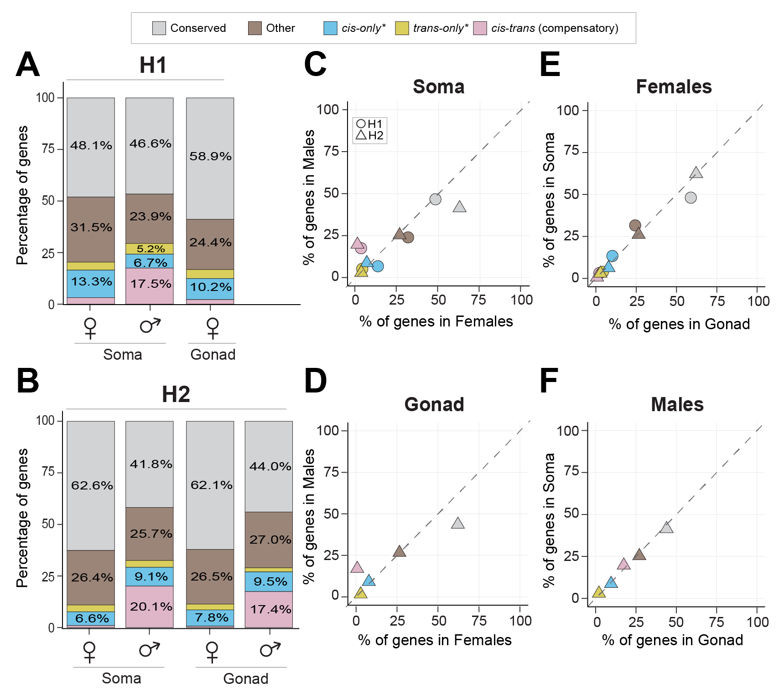
Supplementary Figure S8: Regulatory divergence for X-linked genes. Regulatory divergence for X-linked genes was classified according to a modified scheme due to the hemizygous nature of X-chromosomes in males. cis-only*, trans-only* and cis-trans compensatory genes were identified using this approach in males. All other genes showing significant gene expression deviations were classified under the “Other” category (predominantly including genes displaying cis x trans (compensatory), cis + trans (enhancing) and ambiguous expression) (See methods, Figure S4.2). Such genes are denoted using (*). The number of genes in “cis x trans (compensatory)”, “cis + trans (enhancing)” and “ambiguous” categories in females were summed up to create a “Other” category in females similar to the existing category in males for direct comparison of X-linked regulatory divergence between males and females. (A, B) Barplots depicting the percentage of genes showing different regulatory divergence categories detected in each reciprocal cross H1 (A) and H2 (B) for X-linked genes. (C, D) Scatterplots contrasting percentage of genes in males (y-axis) and females (x-axis) across soma (C) and gonad (D) to identify sex-specific regulatory divergence patterns. (E, F) Scatterplots contrasting difference in abundance of genes between soma (y-axis) and gonad (x-axis) for females (E) and males (F) to identify tissue-specific patterns of regulatory divergence. H1 and H2 have somatic tissue samples, while only H2 has male gonad tissue samples.
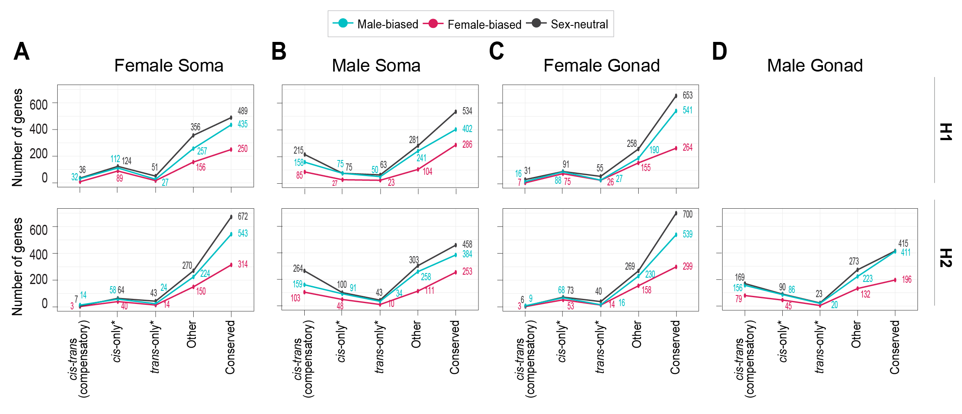
Supplementary Figure S9: cis-trans compensatory regulatory divergence affects misexpression of X-linked sex-biased genes in males. While the broad patterns observed in autosomal genes hold true for X-linked genes (i.e., cis-only divergence disproportionately influences female-biased genes and male-biased genes in hybrid females and males respectively). The misexpression of sex-biased genes in males, especially X-linked genes, is influenced by cis-trans compensatory divergence. Genes with ambiguous expression categorization not shown for clarity.

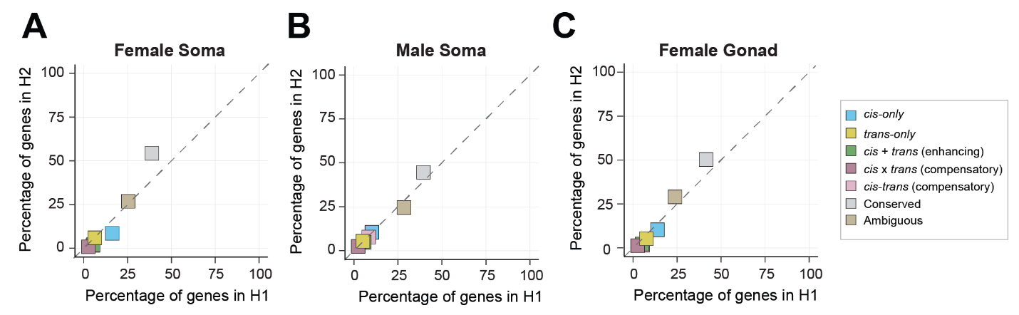
Supplementary Figure S10: Scatterplots comparing percentage of genes in different regulatory divergence categories across H1 (x-axis, maternal C. remanei hybrids) and H2 (y-axis, maternal C. latens hybrids) for female soma (A), male soma (B) and female gonad (C). Overall, H1 has a higher number of misregulated genes than H2 across all samples. cis-only divergence is more common in females while cis-only and cis-trans compensatory divergence in common in males.
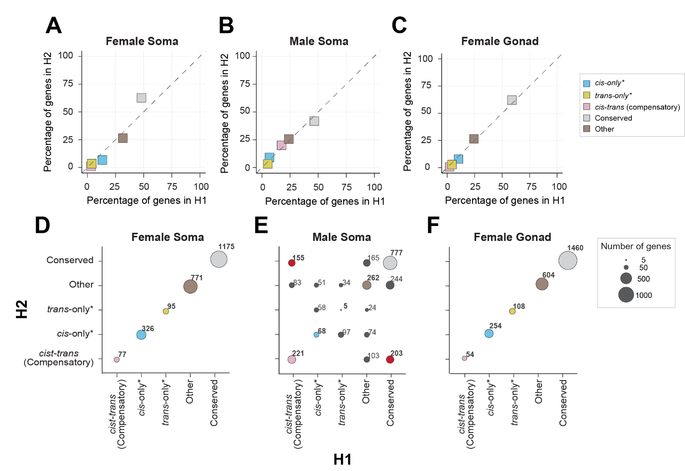
Supplementary Figure S11: Hybrid cross-specific misregulation for X-linked genes is common in males than females. X-linked genes were classified with a slightly different criteria due to their hemizygous nature in males (see methods; Supplementary Figure S4.2). Scatterplots comparing percentage of genes in different regulatory divergence categories across H1 (x-axis) and H2 (y-axis) for female soma (A), male soma (B) and female gonad (C). (D, E, F) Bubble plots contrasting the genes and their regulatory divergence in H1 (x-axis) and H2 (y-axis) to identify genes unique to each hybrid cross with area of the bubble proportional to the number of genes. The bubbles on the diagonals represent the number of genes overlapping between H1 (x-axis) and H2 (y-axis) and red bubbles highlight the number of genes showing cis-trans compensatory divergence exclusively in one hybrid cross. Male soma shows similar pattern of hybrid cross-specific misregulation for both autosomal and X-linked genes (E). However, in females, X-linked genes show no deviation from the diagonal, suggesting that hybrid-cross specific misregulation is not as prevalent in X-linked genes as autosomal genes (D, F). However, the “Other” category in females represents genes displaying cis x trans (compensatory), cis + trans (enhancing) and ambiguous expression and genes in these categories could differ between hybrid crosses.

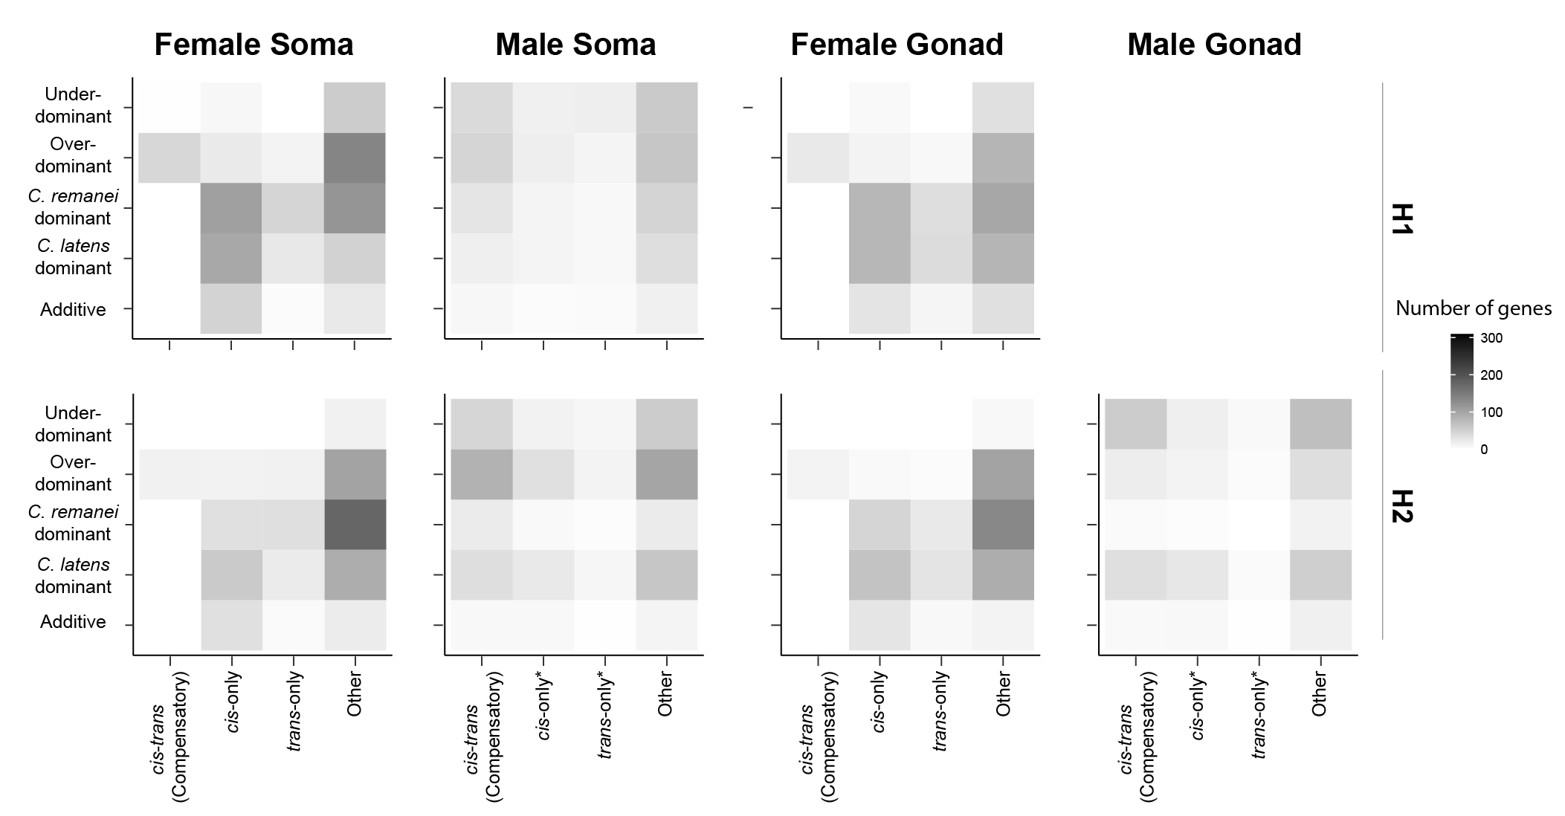
Supplementary Figure S12: Regulatory divergence underlying X-linked transgressive expression. Heatmap with number of genes in different regulatory divergence categories for each expression inheritance profile (y-axis) to identify gene regulatory divergence (x-axis) underlying transgressive expression in X-linked genes. The regulatory divergence was inferred using different criteria for X-linked genes in males due to the hemizygous nature of the X-chromosome in males (see methods; Supplementary Figure S4.2). The pattern of X-linked genes resembles that of autosomes, with cis- and trans- changes playing a role in transgressive expression in males and females.
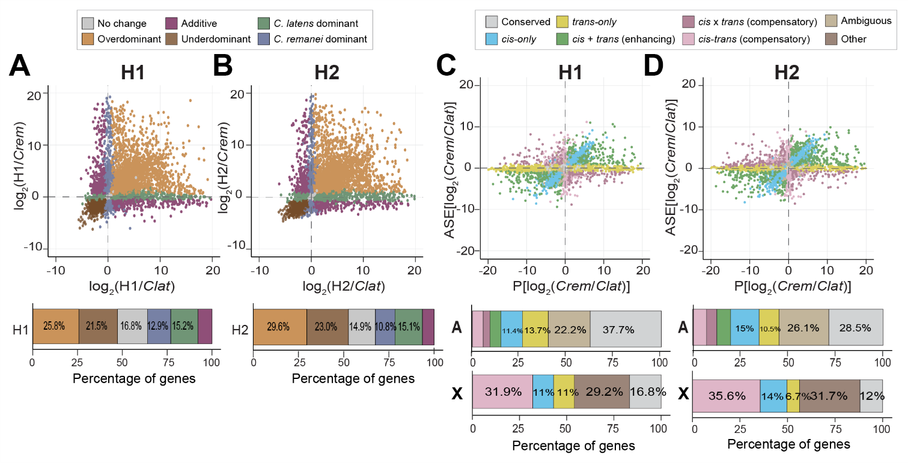
Supplementary Figure S13: Analyses of whole male samples reveal higher misexpression and misregulation in H2 than H1. Gene expression dominance patterns observed in whole male samples of H1 (maternal C. remanei hybrids) (A) and H2 (maternal C. latens hybrids) (B). (n_{H1, No change} = 1989 or ~17%; n_{H2, No change}=1743 or ~15%; n_{H1, Underdominant} = 2537 or ~21%; n_{H2, Underdominant} = 2689 or ~23%; n_{H1, Clat} = 1794 or ~15%; n_{H2, Clat} = 1768 or ~15%; n_{H1, Cre} = 1521 or ~13%; n_{H2, Cre} = 1264 or ~11%; n_{H1, Additive} = 924 or ~8%; n_{H2, Additive} = 762 or ~6.5%). Regulatory divergence based on allele-specific expression analysis in whole male samples of H1 (C) and H2 (D). Bars underneath the scatterplots represent proportion of genes in different gene expression and regulatory divergence categories for autosomal genes and X-linked genes. X-linked regulatory divergence was classified according to a modified scheme due to the hemizygous nature of X-chromosomes in males. cis-only, trans-only and cis-trans compensatory genes were identified using this approach in males. All other genes showing significant gene expression deviations were classified under the “Other” category (including genes displaying cis x trans (compensatory), cis + trans (enhancing) and ambiguous expression) (See methods, Figure S2).

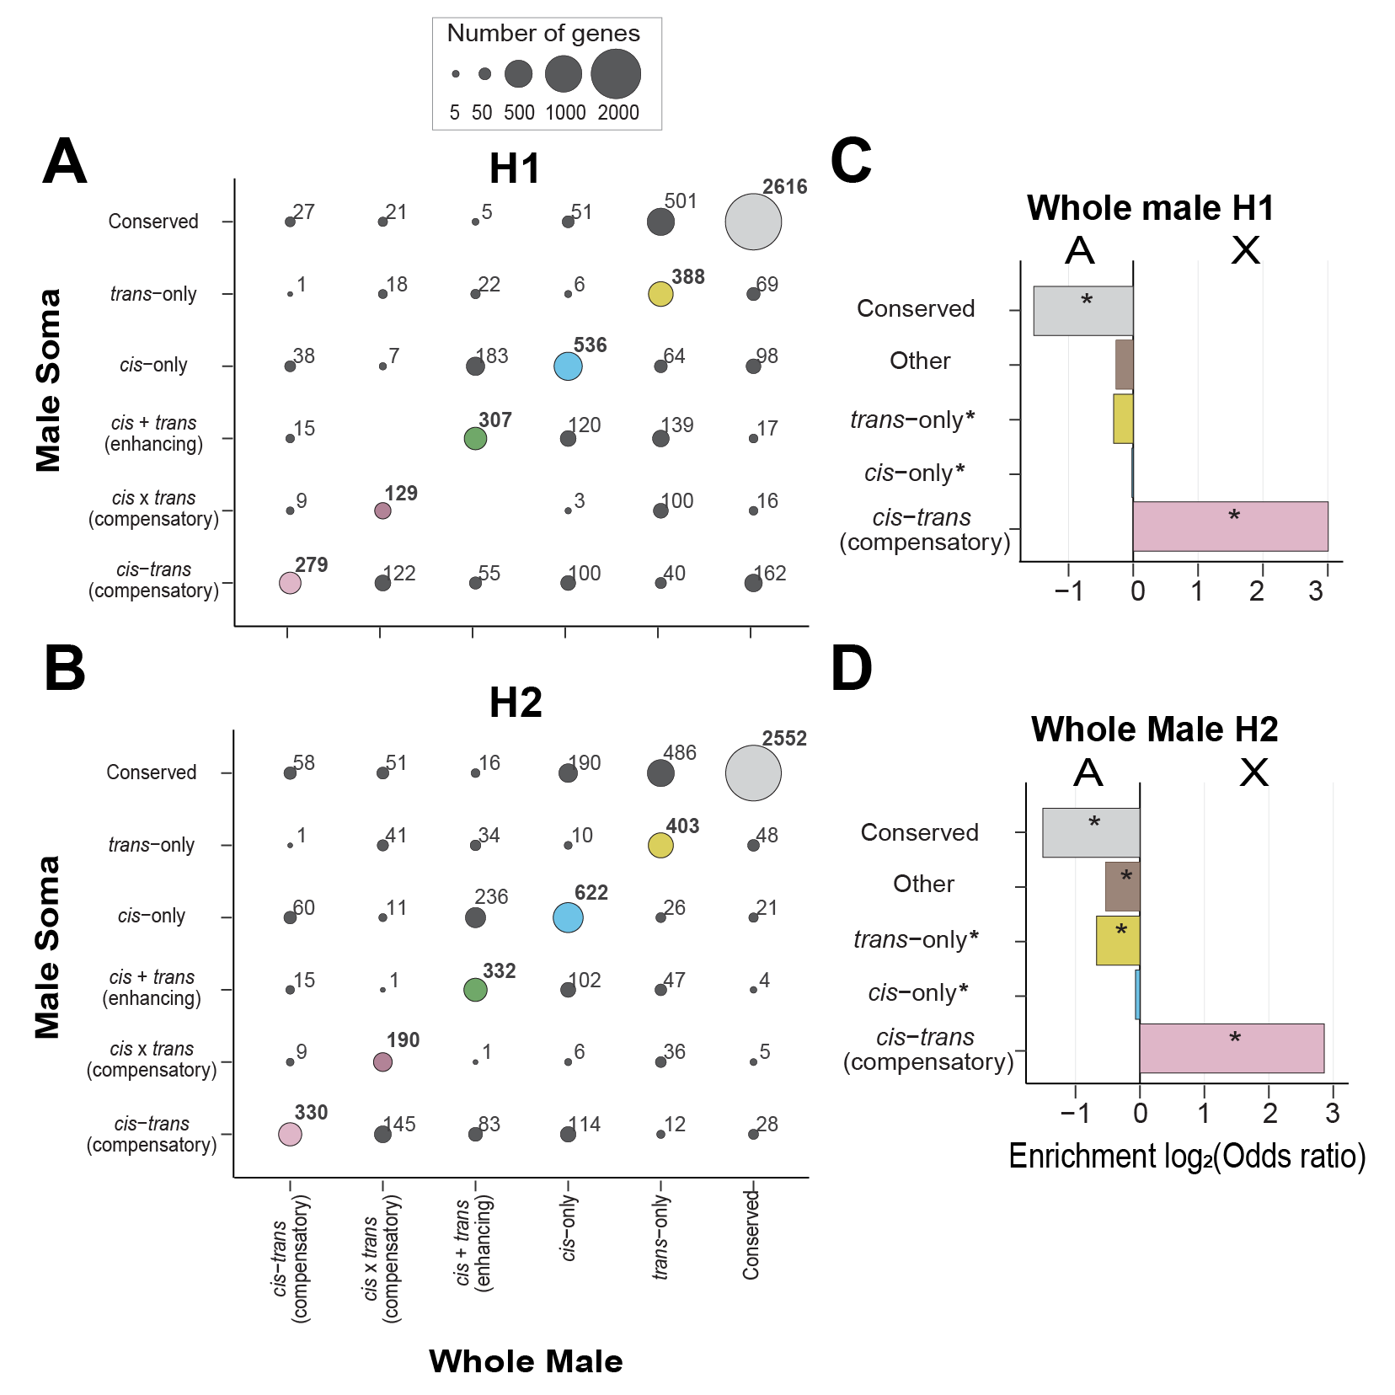
Supplementary Figure S14: X-chromosome displays an enrichment for cis-trans compensatory divergence in H1 and H2 hybrid cross. (A, B) Comparison of regulatory divergence between male soma (y-axis) and whole male samples (x-axis) in H1 (maternal C. remanei hybrids) (A) and H2 (maternal C. latens hybrids) (B). Bubble area is proportional to the number of genes and bubbles on the diagonals display overlap in the number of genes between H1 and H2. X-linked and ambiguous genes not shown for clarity. Most genes fall on the diagonal except for genes displaying trans-only divergence indicating similarity in regulatory divergence between samples for autosomal genes. However, comparison between whole male samples and male soma for X-linked genes displays substantial sample-specific misregulation (Supplementary figure S11). (C, D) Enrichment of genes displaying regulatory divergence between autosomes and X-chromosomes in whole male sample. Positive values represent enrichment on X-chromosome and negative values represent enrichment on autosomes. The X-linked genes in males were categorized based on a slightly different comparison (see methods) (Supplementary Figure S2). we categorized genes displaying cis×trans (compensatory) divergence, cis+trans (compensatory) divergence, and ambiguous expression into the "other" category for direct comparison between X-linked and autosomal genes (see methods).
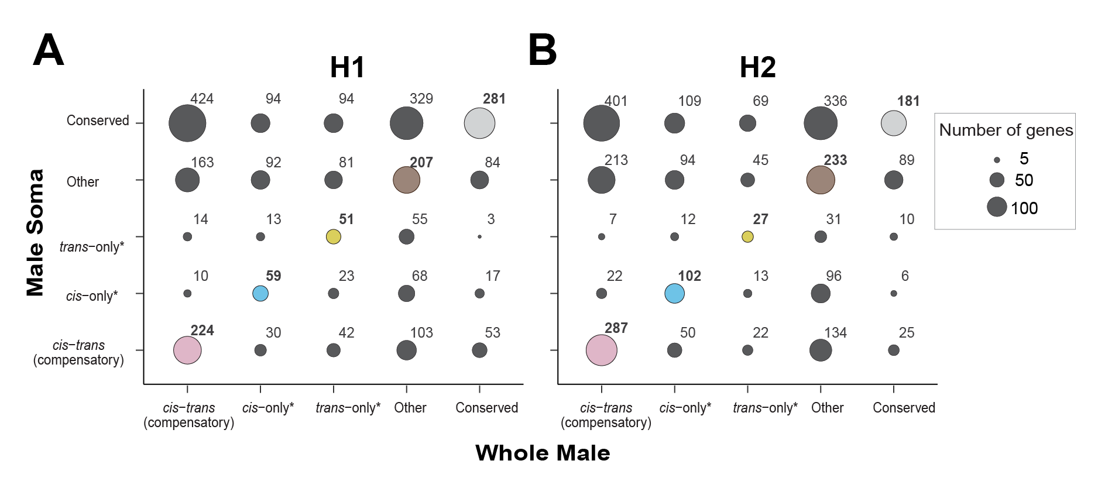
Supplementary Figure S15: Regulatory divergence substantially differs between male soma and whole male samples for X-linked genes. (A, B) Comparison of regulatory divergence between male soma (y-axis) and whole male samples (x-axis) in H1 (A) and H2 (B). Bubble area is proportional to the number of genes and bubbles on the diagonals display overlap in the number of genes between H1 and H2. Compared to autosomal genes, X-linked genes display >50% genes uniquely classified in either whole male sample or male soma sample emphasizing that expression data from whole animals and tissue samples is substantially different, especially for X-chromosome.

